Network configuration in VMware workstation

1. Open windows command prompt(host machine) and type ipconfig

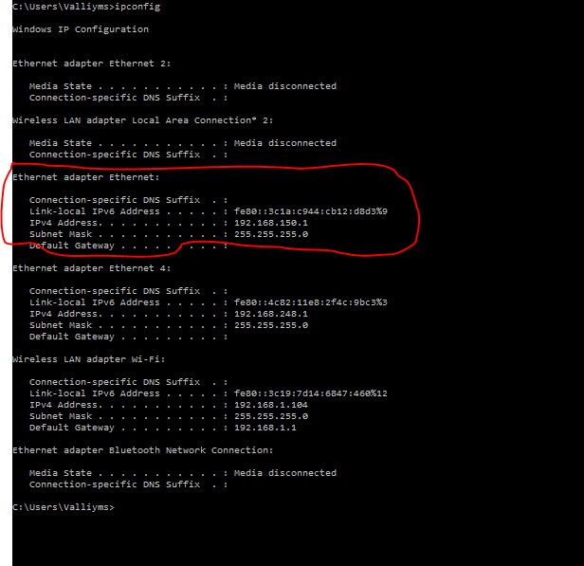

Here is the output of ipcofnig

C:\Users\Valliyms>ipconfig

Windows IP Configuration

Ethernet adapter Ethernet 2:

Media State . . . . . . . . . . . : Media disconnected

Connection-specific DNS Suffix . :

Wireless LAN adapter Local Area Connection\* 2:

Media State . . . . . . . . . . . : Media disconnected

Connection-specific DNS Suffix . :

Ethernet adapter Ethernet:

Connection-specific DNS Suffix . :

Link-local IPv6 Address . . . . . : fe80::3c1a:c944:cb12:d8d3%9

IPv4 Address. . . . . . . . . . . : 192.168.150.1

Subnet Mask . . . . . . . . . . . : 255.255.255.0

Default Gateway . . . . . . . . . :

Ethernet adapter Ethernet 4:

Connection-specific DNS Suffix . :

Link-local IPv6 Address . . . . . : fe80::4c82:11e8:2f4c:9bc3%3

IPv4 Address. . . . . . . . . . . : 192.168.248.1

Subnet Mask . . . . . . . . . . . : 255.255.255.0

Default Gateway . . . . . . . . . :

Wireless LAN adapter Wi-Fi:

Connection-specific DNS Suffix . :

Link-local IPv6 Address . . . . . : fe80::3c19:7d14:6847:460%12

IPv4 Address. . . . . . . . . . . : 192.168.1.104

Subnet Mask . . . . . . . . . . . : 255.255.255.0

Default Gateway . . . . . . . . . : 192.168.1.1

Ethernet adapter Bluetooth Network Connection:

Media State . . . . . . . . . . . : Media disconnected

Connection-specific DNS Suffix . :

C:\Users\Valliyms>

1. Open network and sharing center and check for the Ethernet

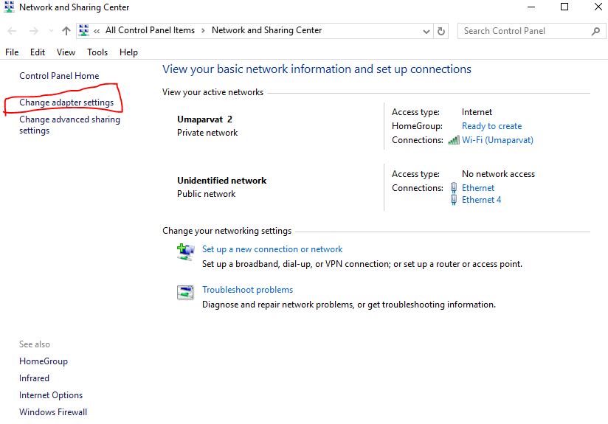

Click Change adapater settings and right click the Ethernet adapter and right click -> select properties

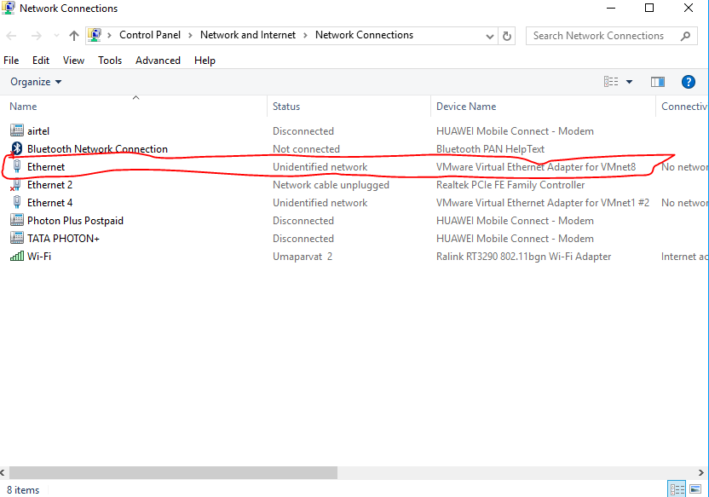

Select IPV4 and click properties

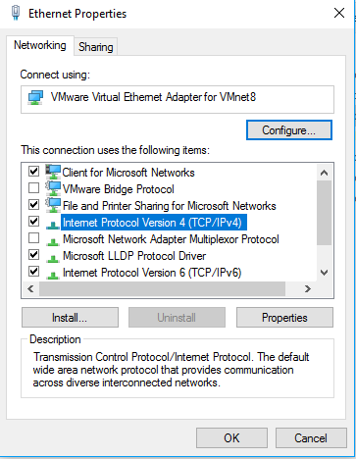

Mention the adapter IP and default gateway

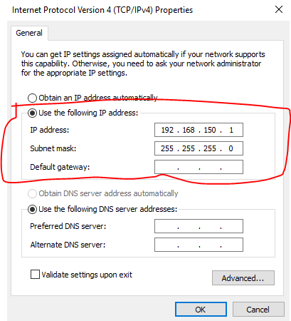

1. Open vm ware work station and click edit -> vm ware network editor

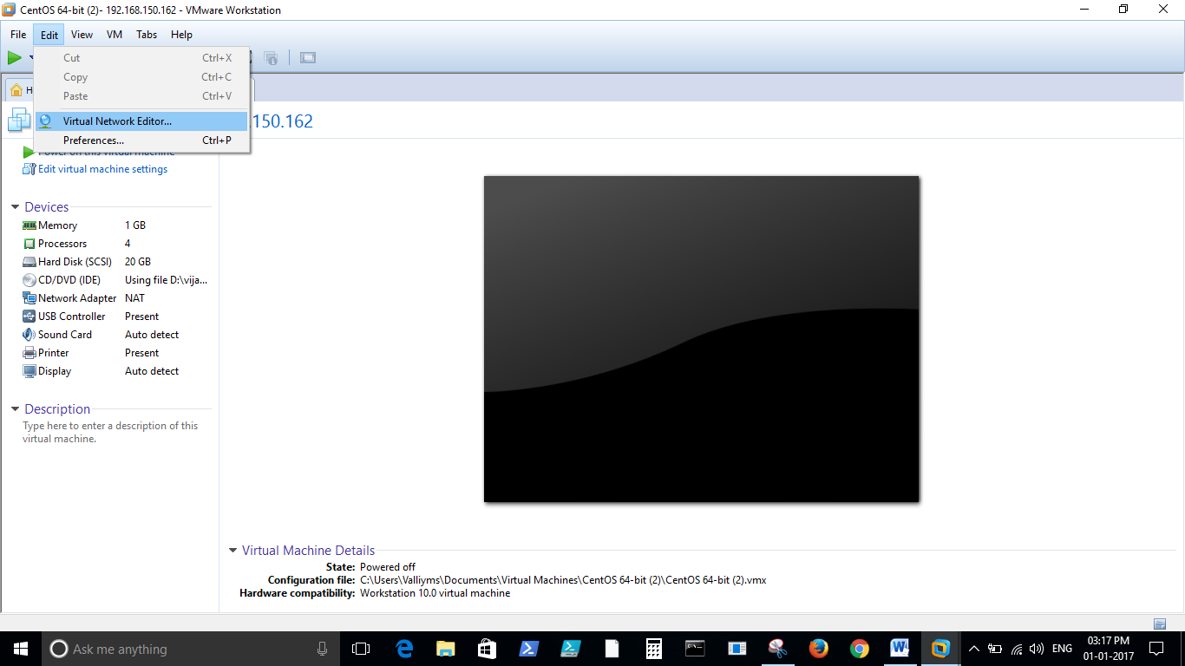

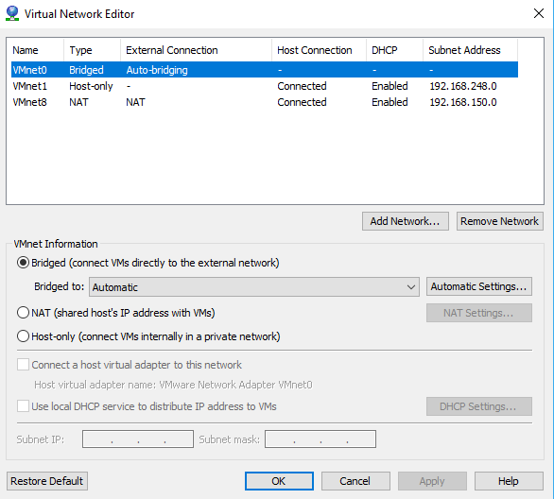

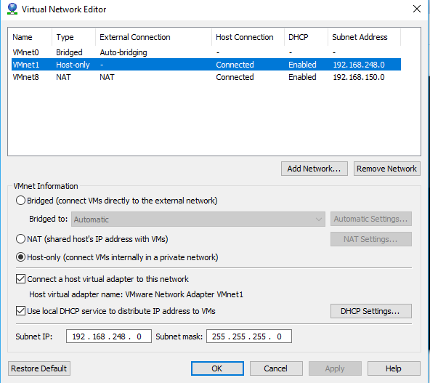

DHCP setting of VMnet1

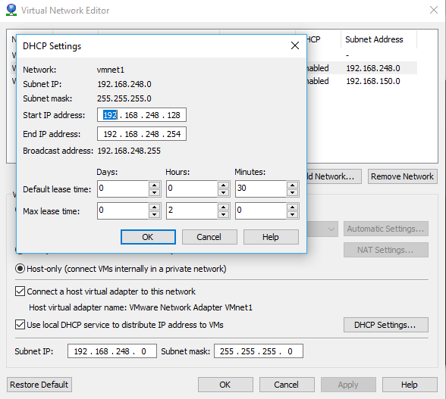

VMnet 8 setting

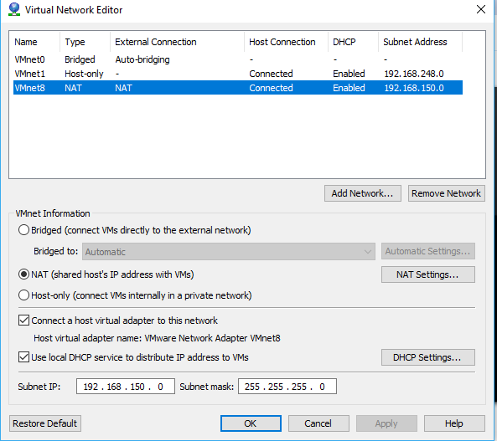

DHCP setting of vmnet 8

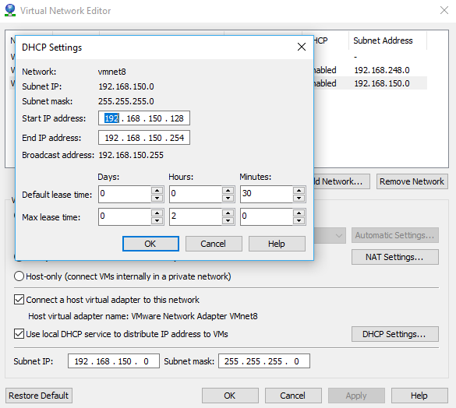

NAT settings of VMnet 8

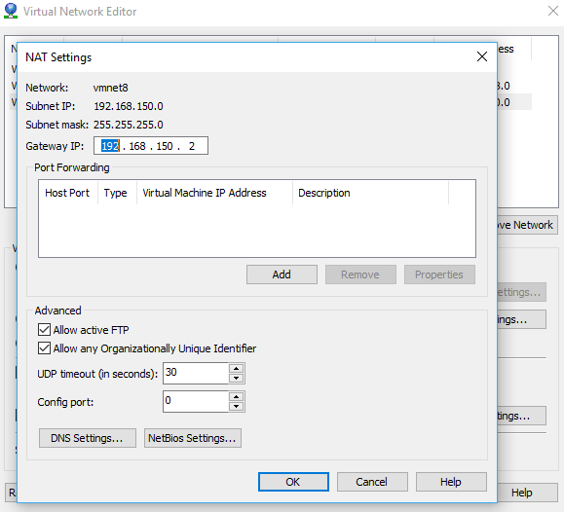

1. Type ifconfig or ip a in the unix vm to identify the Ethernet card

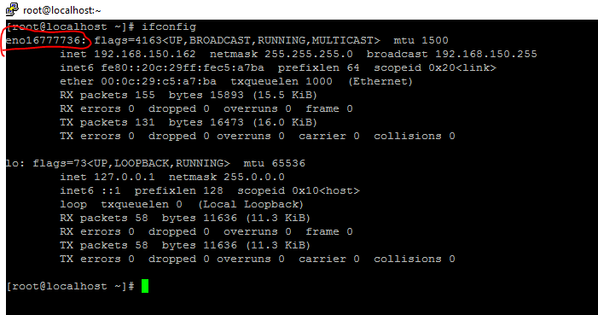

1. In the vm set the network information in /etc/sysconfig/network-scripts/ifcfg-<ether net card>

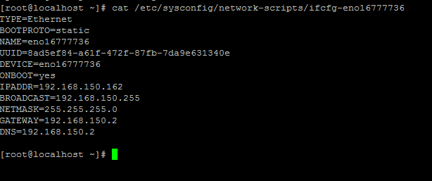

1. Set the nameserver in /etc/resolv.conf

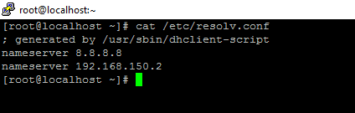

1. Restart the network service . Now the VM can have internet and also accessible from Host machine through putty.